1. GitHub Repository Setup Instructions
Create a new GitHub repository and name it csd-340
Enter a description
Make the repository public and “Initialize this repository with a README.md” file
Choose “Create repository”

https://github.com/bamachaos/csd-340.git

2. Local Directory Setup Instructions
Open a new terminal window (cmd for windows/terminal for macOS) and navigate to your local “csd” directory
Sign in to GitHub (if not already) and click on your repository
Select the green “Code” button and copy the URL. In your local terminal window, verify you are in the correct directory (csd) and type
git clone <paste URL>
Verify the repository was cloned by typing
Windows: dir
macOS: ls
Take a screenshot of the results of either 'dir' or 'ls'

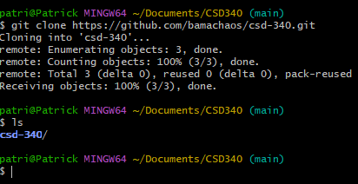

3. Modify README.md
- Add an h1 header with the title of “CSD 340 Web Development with HTML and CSS” to your GitHub repository
- Hint: refer to the Markdown Cheatsheet
- Add an h2 header with the title “Contributors” to your GitHub repository
- Underneath the h2 header add two bullet points, one for your Instructor's name and one for your first and last name
- Take a screenshot of your GitHub repository landing page

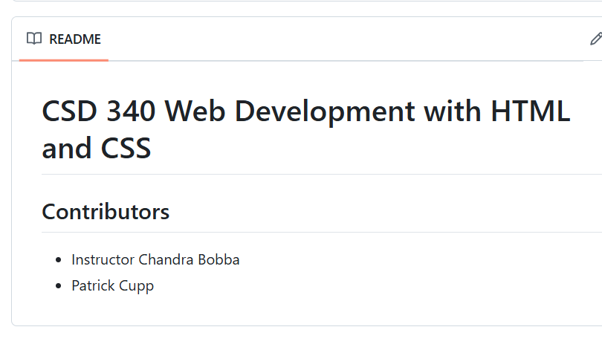

4. Repository Structure
We will be following Python’s official naming conventions for directories and files, which means all folders and files must be named as lowercase values with words separated by dashes. For example, if I had a folder named My Documents, in JavaScript I would name this folder my-documents. It might be easier to create the module folders as we move through the course.

- Module folders (i.e., module-<number>)
- Each module will have its own folder with its associated assignment files
- For example:
- module-1
- assignment-1
- assignment-2
- assignment-3
- module-2
- assignment-1
- assignment-2
- assignment-3

